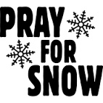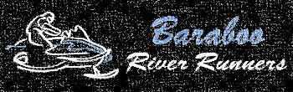

**Give Thanks**

**Newsletter**

**November 2015**

**Next Club Meeting:**

**\* Wed. November 11, 2015 @ 7:00 pm**  **Location: Pizza Ranch**

**Upcoming meeting dates and locations for 2015/2016 season:**

~ 7pm, December 9- Farm Kitchen ~ 7pm, March 9- The Barn Restaurant

~ 7pm, January 13- Pumphouse ~ 7pm, April 13- Towne Lounge

~ 7pm, February 10- Location TBD

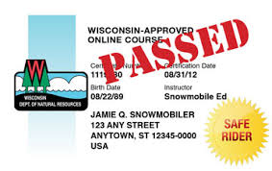***Snowmobile Safety Classes: Baraboo- December 7, 8, and 12 Mon. &Tue. 6-8pm & Sat 8am-12pm***

***Baraboo contact: Mike Cole 608-356-6968***

***Reedsburg- November 9, 10, and 14 Mon. &Tue. 6-8pm & Sat 8am-12pm***

***Reedsburg contact: Jim Wittenberger 608-235-5668***

***Happy Thanksgiving to everyone! Praying you will all have save travels and a very blessed time with family and friends!***

***An election of officers was held at our October meeting for the President and Treasurer- Al Szymanski, Treasurer, and Dave Dahlke, President, both accepted the nomination to continue for 2 more years, and was voted in to do so! Thank you and congratulations to you both, as you contribute tremendously to our club!***

***A special thank you for everyone who came out, and/ or called to give their input /vote on our special meeting held this past week. We had a great turnout, and I believe this was a pivotal time in our club and many other clubs belonging to the Association of Sauk County Snowmobile Clubs. Working together for the greater good of all of us in Sauk County! For more detailed information on the meeting I have attached the Meeting minutes from the Oct. 29 special meeting that the email went out to everyone for. If you weren’t able to make the meeting you can see more details on what was discussed and how other clubs have stepped up in this matter to move our county trail system forward!***

***We will be entering our groomer and raffle sled again in the Holly Jolly Light Parade this year on Sat. November 21 Decorating will be at Pete’s Glass on Thursday and Friday Evenings the 19th and 20th at 5PM, so come one, come all! The Parade Theme is: YOUR FAVORITE CHRISTMAS MEMORY! We can use as many lights as you all can lend, especially if you have lit up snowflakes or any special lights or ideas for this theme! Dave Dahlke is heading up the decorating this year, so let him know if you have any questions or what you have to help out! Contact him at:*** [***djdahlke@yahoo.com***](mailto:djdahlke@yahoo.com)

***Tickets available for our Vintage Snowmobile Raffle- contact Eric Lewison for raffle tickets to sell for this year at:*** [***Eric@don-rick.com***](mailto:Eric@don-rick.com)

***Save the Dates:***

***Our annual landowner appreciation event/chili feed will be held at the Pumphouse Sports Bar and Grill in Baraboo on Saturday, January 16, 2016. We’re always looking for raffle donations, so if you can come up with some goods, related to anything not just snowmobile! We have many men, women, and children at this event and they all love to win prizes!! If you’ve been able to attend you know how much fun this event is for everyone!***

***The Association of Sauk County will be holding their annual Cash Raffle Event on Saturday, March 12th, 2016 at the Fore Season’s at the Golf Course in Baraboo this year. Cash raffle tickets are also available! Let us know if you want to purchase or get some tickets to sell and we will get some for you!***

***\*Dear Members,***

***I am in the process of gathering all of the AWSC cards for those that renewed and getting them, along with the Rewards Cards for our members and the 2015/2016 Baraboo River Runners Decals out in the mail soon! With all of the different avenues of payment, I have quite a time figuring out who would like which color for their decals. I have the ones who renewed by filling out their forms and designated a sticker preference, however if you did not fill out a renewal form or paid online I have no way of knowing what your preference is. If you have a preference, I will do my best to get you what you’d like if you respond back to this email with your color choices (2) in the next day or two, otherwise I will just have to randomly pick for you. The options are Blue, Black, Green, Yellow, or Red. Thank you for being a valued Club Member!***

***Wendy Senger,***

***Secretary/ Membership Coordinator***

***Baraboo River Runners***

**Gold Sponsors:**

# farm kitchen baraboo motors groupdon rick insurance pumphouse sports bar don larson superstore balfanz insurance glacier valley ford hoppe transport totl marketing

Silver Sponsors: Bronze Sponsors:

Rob Thayer

C:\Users\Sengers\Pictures\bnb.jpg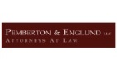 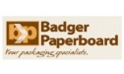 turner bp and water care hills wiring petes glass luther farms big o's trailers

Glacier Rock / Clarion West - Baraboo, WI viking express market baraboo inn 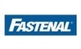 brute construction